Will Arsenal finish first?

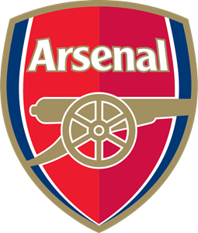

Arsenal London is a football club that has huge chance to win Premier League in season 2022/2023. In this paper I will try to explain why this London club has progressed so much during last few months. For the purpose of analysis data from fbref.com is used.

In my analysis I would like to answer to the following questions:

1. What are the reasons that particular club became champion in the past?
2. How did Arsenal progress during last 5 seasons?
3. Will Arsenal be the next Premier League champion?

## 1. How do teams become champions?

Among all footbal proverbs the most overused one is that ‘Attack wins you games, defence wins you title. Let’s check then if it is a true in the context of Premier League.

Firstly, we should look at defence of champions from season 2017 to 2022. To compare it we will use xGA/90 (expexted goals allowed per match) and GA (goals allowed) statistics. Based on discussed proverb, the best team defensively should always (or at least in most cases) win the title. Let’s have a look at the below diagram and find out how to be the most effective defence in Premier League.

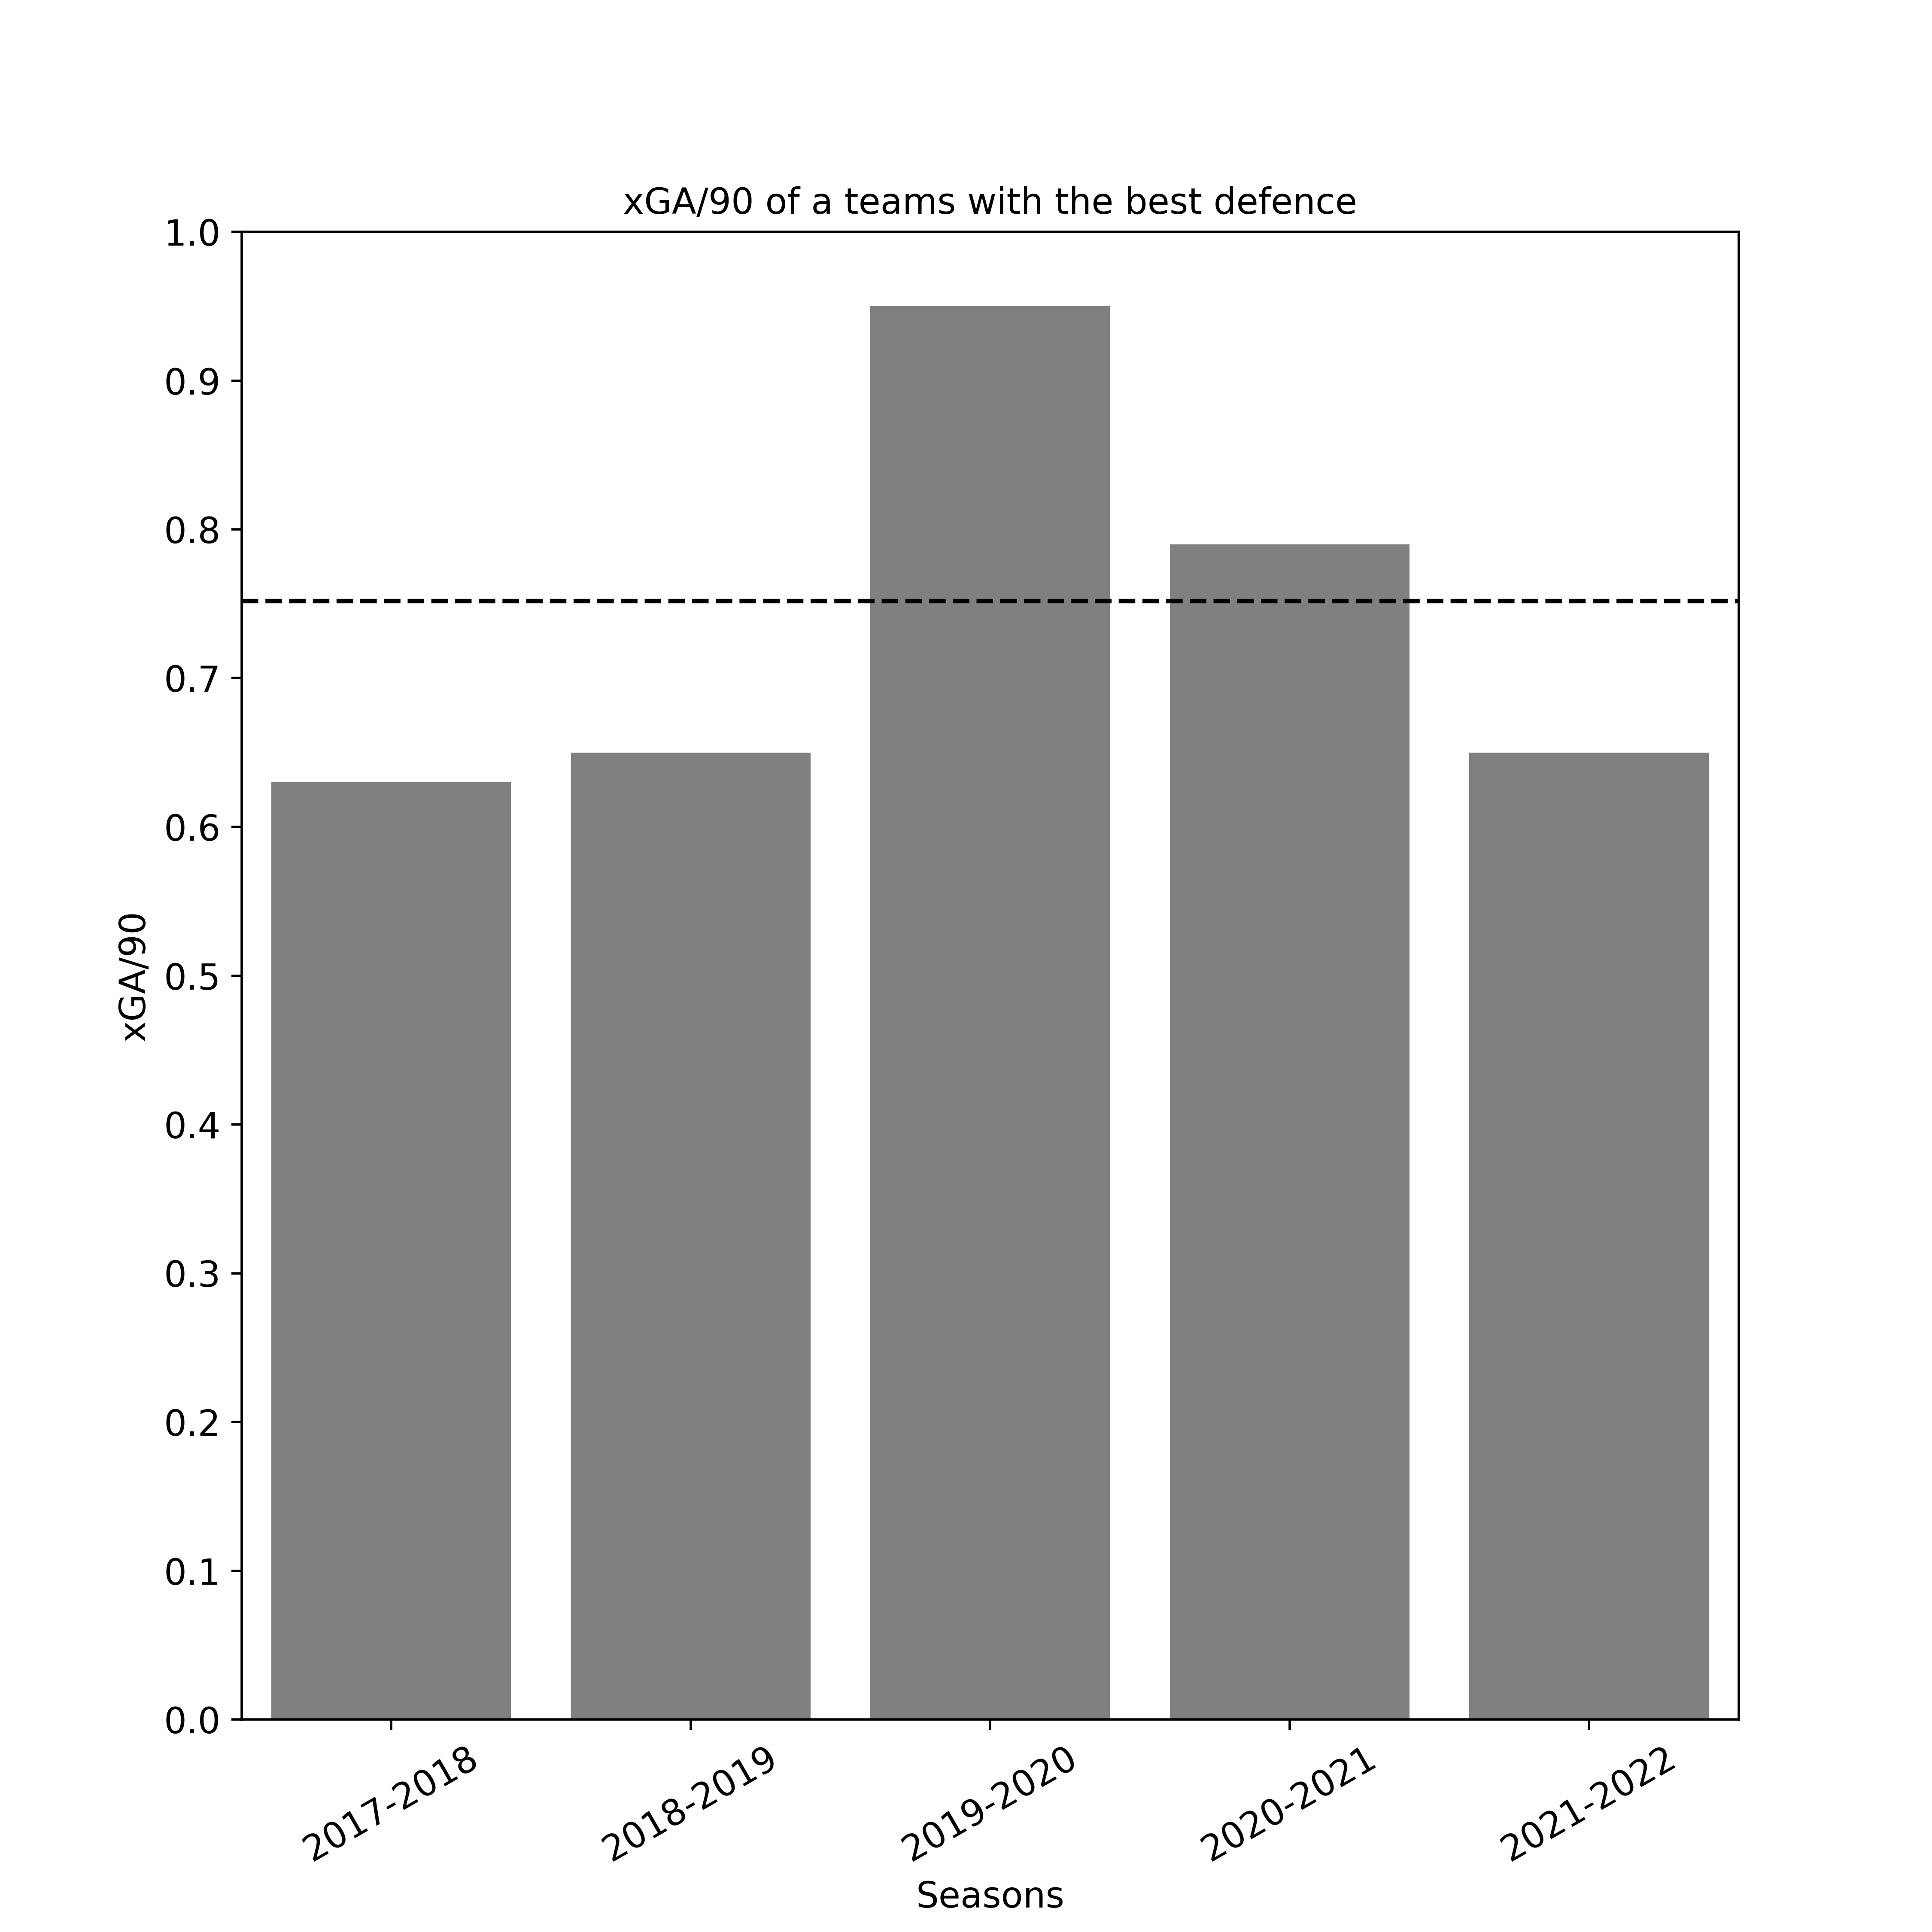

Based on the above diagram, to become the best defence in a league team needs to have expected goal allowed per 90 minutes statistic on average level of 0.75. It means that squad that is the best in a league allows for a less than 1 offensive action that for 100% ends with a goal. What is even more interesting, during last 5 seasons Manchester City won title of the best defence in the league. Good job Pep. Nevertheless, let’s see if it always guaranteed trophy:

As you can see in 4 out of 5 seasons, the best defensively team won a title. Conclusion is that the best defence does not guarantee championship, but it significantly increase probability of winning it.

We went through defensive aspects of a game, so now it is time to compare it with offensive. During last seasons a lot of articles, tv programs etc. were focused on rivalry between Liverpool and Manchester City, so it is time to compare it with statistics. This time we will take a look at xG/90 (expected goals per 90 mins) of the best offensive team in each season and GF (Goals For) of all teams in the League.

Starting with xG/90 to be the best offensive squad in the league, team needs to create chances to score at leas 2.15 goals per game on average. 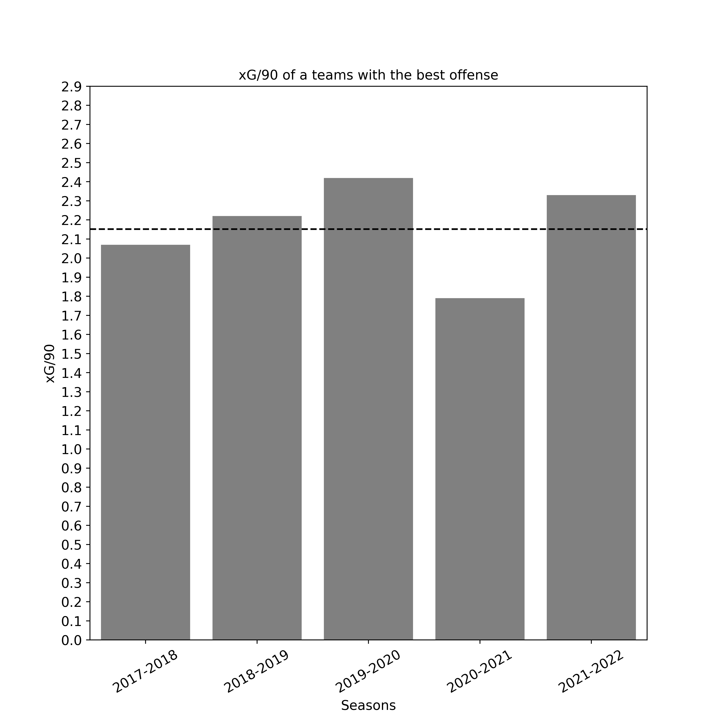Although does it mean that scoring goals guarantees a title?



As you can see on scatter plot in 4 out of 5 seasons team which won championsip did not score the most goals. Thus we can conclude (simillarly to defensive statistics), that offense defence does not guarantee championship, but it significantly increase probability of winning it. Which is even more interesting the ratio is the same, as for Goals Allowed. In 80% of seasons when team scored more goals or conceded less, it won the title.

**2. How did Arsenal progress during last 5 seasons?**

The main topic of this paper is assessing Arsenal’s chance to win the title this season. Thus we need to focus on their progress throughout last 5 years. Firstly, let’s have a look at positions of The Gunners from 2018 to 2022:

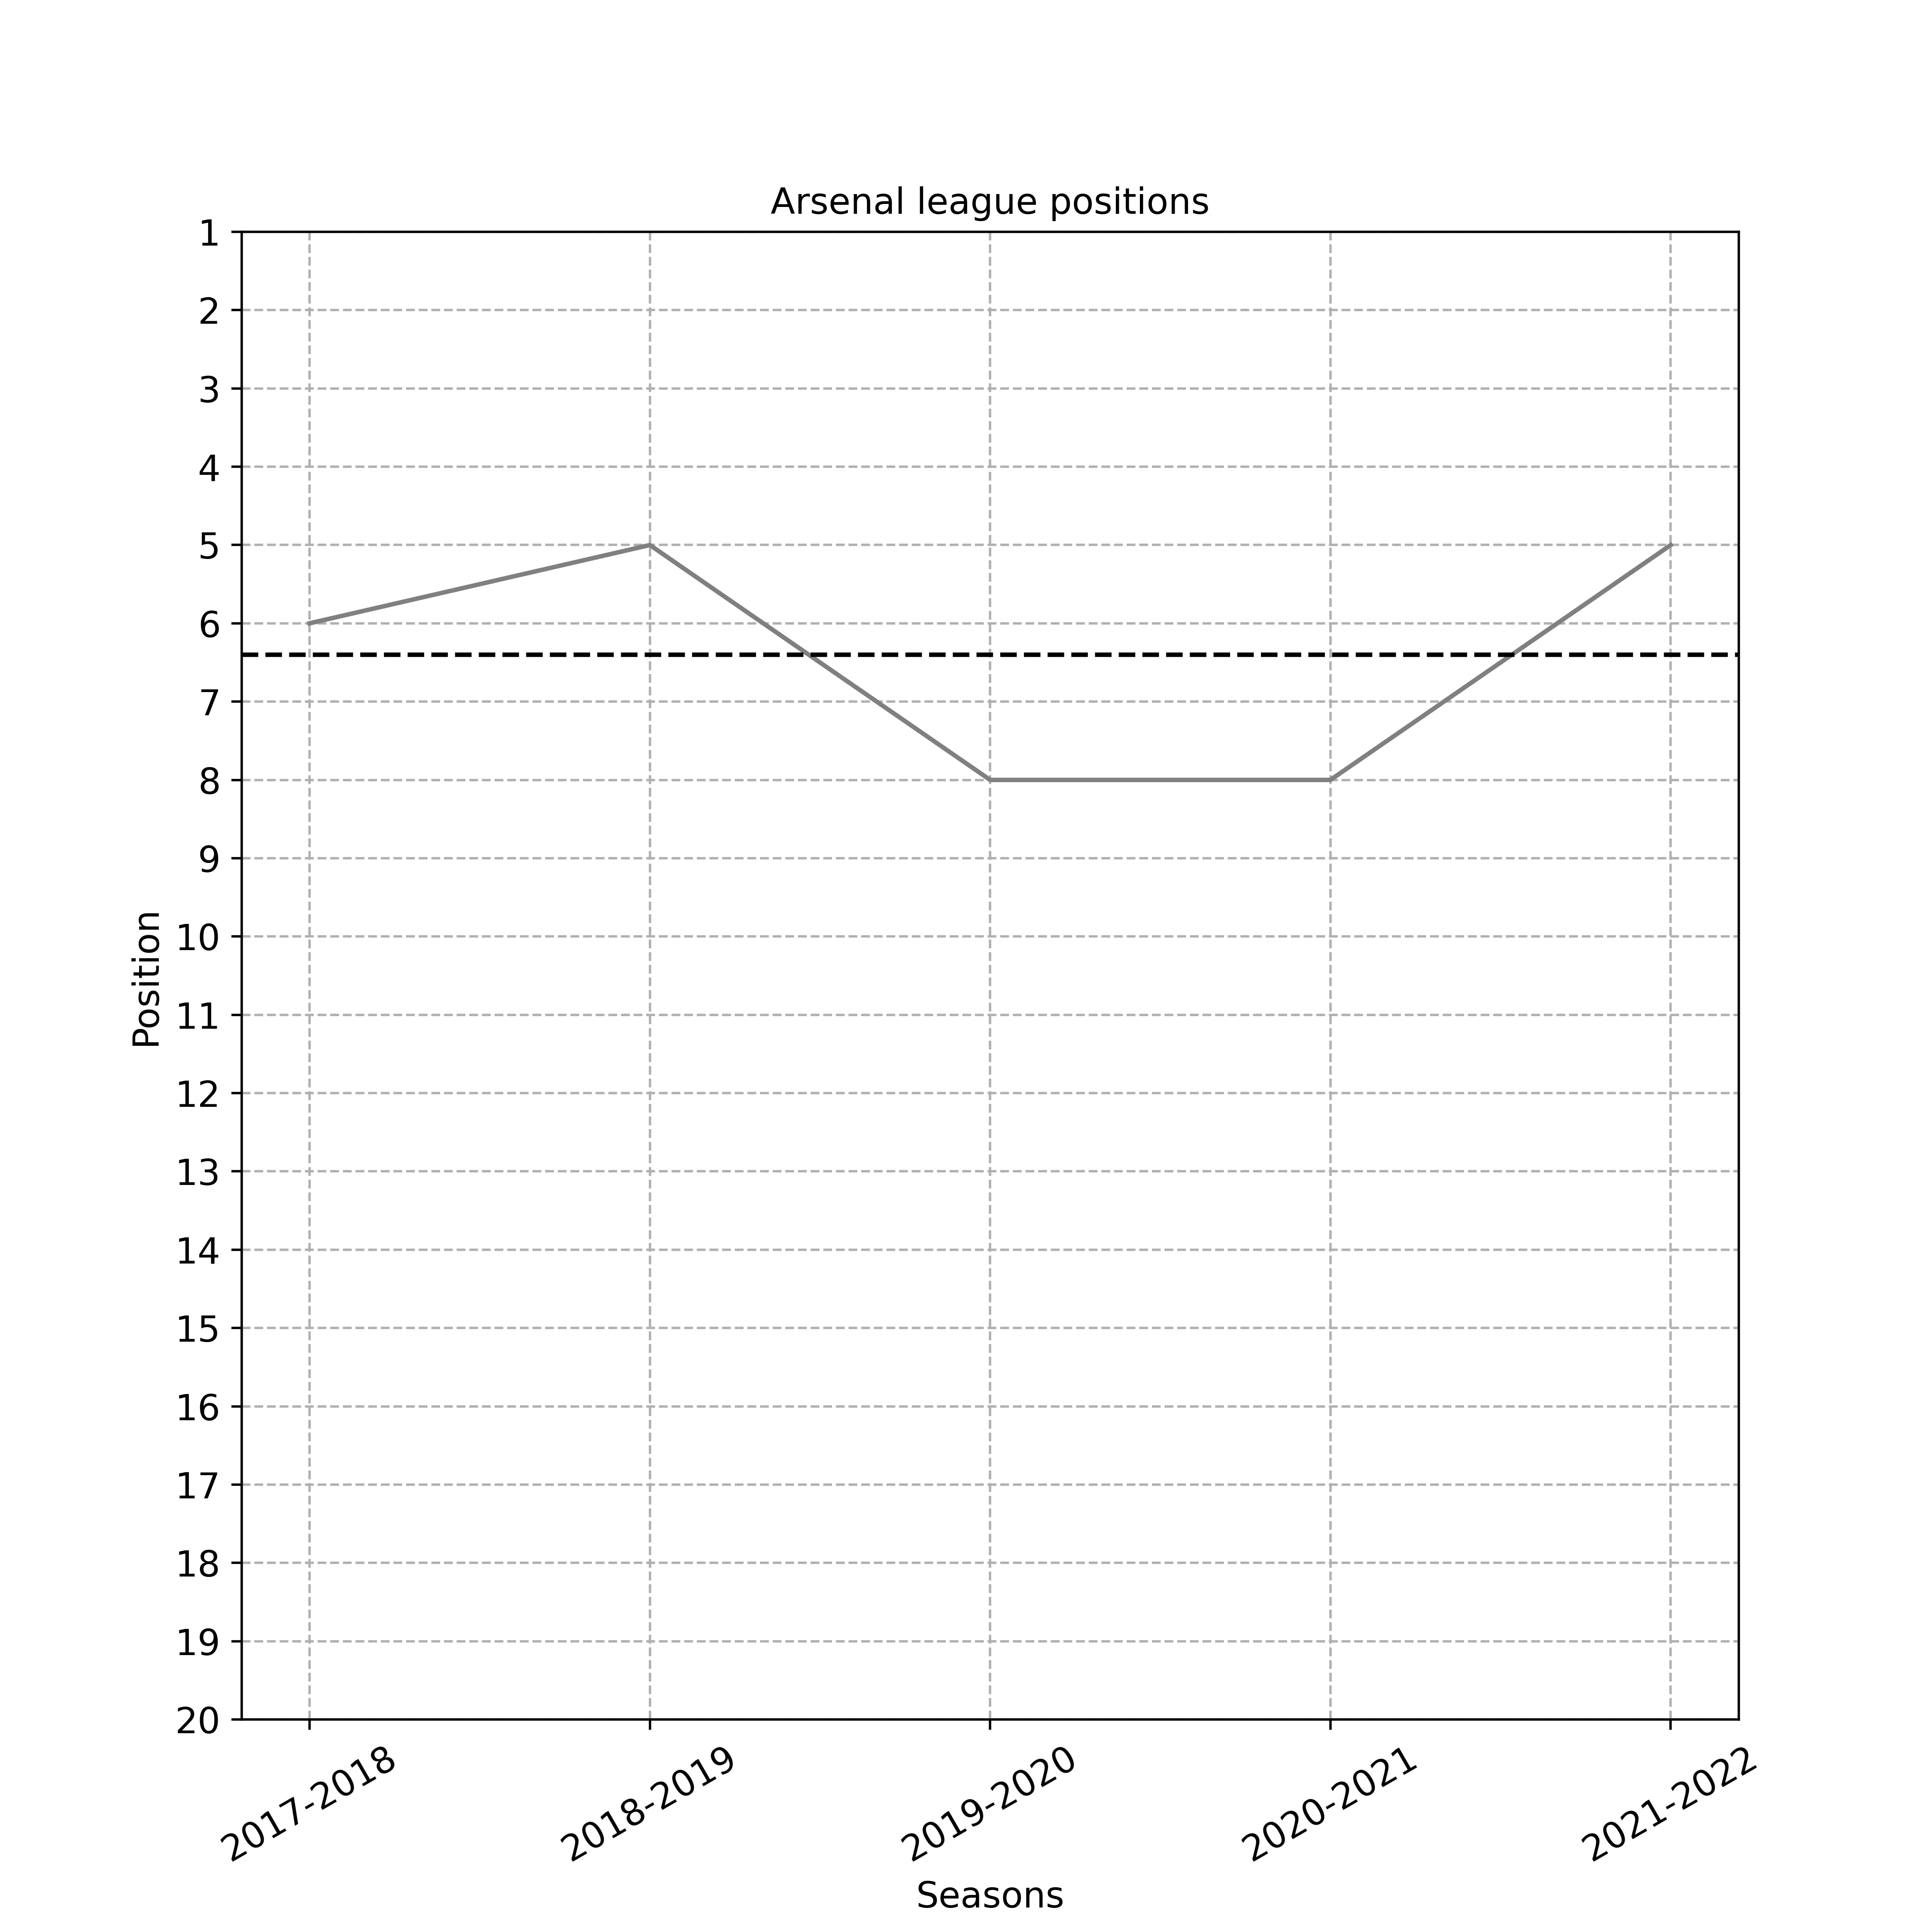

As you can see positions fluctuate between 8 and 5. Arsenal has never reached top 4 that guarantees participation in Champions League. Moreover